Nature Photography as a Spiritual Practice
Tom Wilson and Tricia Templeton
Instructions for living a life:
Pay attention.
Be astonished.
Tell about it.
-Mary Oliver-
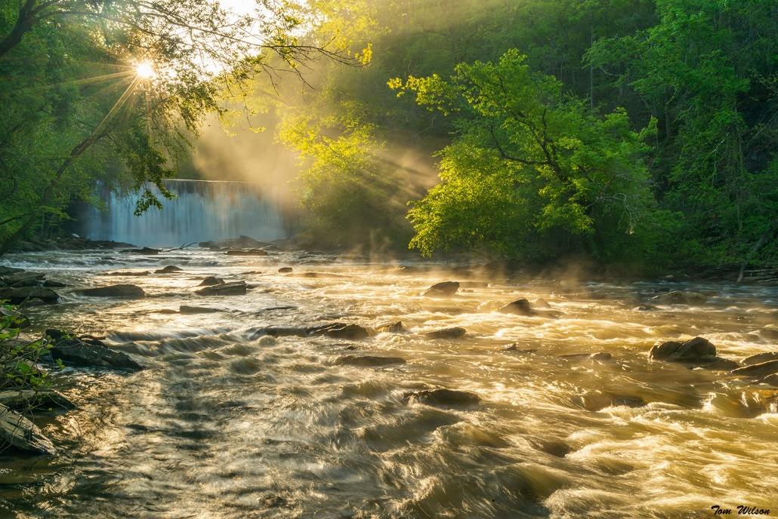

Saint Dunstan’s Episcopal Church, Saturday, November 16th.
8:00 am- noon Saint Dunstan’s
Lunch noon to1:00pm on your own
Field Session 1:30pm to 5:30pm for practical field work.
Most appropriate for those using DSLR or advanced mirrorless cameras.
How to capture moments of awe in photographs. We will cover lighting, composition, lenses and filters and how they affect the image, the exposure triangle, the why of your images and how to put them to work.
Course fee is $50.00 which will go to the St. Dunstan’s grounds fund. Fees payable to St. Dunstans @____________ Proceeds will be donated to Episcopal Relief and Development for Hurricane Helene Relief.
Bring your camera equipment and a good case for carrying it with you and be prepared to be outside for several hours in the afternoon. You should have on good walking shoes for trails, although we will not be walking far. You should have good clothing for cold and rain if needed as well as sun protection, water and other essentials for being comfortable outdoors.

